*#Required Libraries*

**import** numpy **as** np

**import** pandas **as** pd

**import** matplotlib.pyplot **as** plt

**import** seaborn **as** sns

**from** sklearn.preprocessing **import** LabelEncoder

**from** sklearn.preprocessing **import** MinMaxScaler

**from** sklearn.model_selection **import** train_test_split

**from** sklearn.preprocessing **import** StandardScaler

In [2]:

*#Dataset path initialization*

df**=**pd**.**read_csv('/content/Churn_Modelling.csv')

**Dataset Summary**

In [3]:

df**.**head()

Out[3]:

|  | **RowNumber** | **CustomerId** | **Surname** | **CreditScore** | **Geography** | **Gender** | **Age** | **Tenure** | **Balance** | **NumOfProducts** | **HasCrCard** | **IsActiveMember** | **EstimatedSalary** | **Exited** |
| --- | --- | --- | --- | --- | --- | --- | --- | --- | --- | --- | --- | --- | --- | --- |
| **0** | 1 | 15634602 | Hargrave | 619 | France | Female | 42 | 2 | 0.00 | 1 | 1 | 1 | 101348.88 | 1 |
| **1** | 2 | 15647311 | Hill | 608 | Spain | Female | 41 | 1 | 83807.86 | 1 | 0 | 1 | 112542.58 | 0 |
| **2** | 3 | 15619304 | Onio | 502 | France | Female | 42 | 8 | 159660.80 | 3 | 1 | 0 | 113931.57 | 1 |
| **3** | 4 | 15701354 | Boni | 699 | France | Female | 39 | 1 | 0.00 | 2 | 0 | 0 | 93826.63 | 0 |
| **4** | 5 | 15737888 | Mitchell | 850 | Spain | Female | 43 | 2 | 125510.82 | 1 | 1 | 1 | 79084.10 | 0 |

In [4]:

df**.**tail()

Out[4]:

|  | **RowNumber** | **CustomerId** | **Surname** | **CreditScore** | **Geography** | **Gender** | **Age** | **Tenure** | **Balance** | **NumOfProducts** | **HasCrCard** | **IsActiveMember** | **EstimatedSalary** | **Exited** |
| --- | --- | --- | --- | --- | --- | --- | --- | --- | --- | --- | --- | --- | --- | --- |
| **9995** | 9996 | 15606229 | Obijiaku | 771 | France | Male | 39 | 5 | 0.00 | 2 | 1 | 0 | 96270.64 | 0 |
| **9996** | 9997 | 15569892 | Johnstone | 516 | France | Male | 35 | 10 | 57369.61 | 1 | 1 | 1 | 101699.77 | 0 |
| **9997** | 9998 | 15584532 | Liu | 709 | France | Female | 36 | 7 | 0.00 | 1 | 0 | 1 | 42085.58 | 1 |
| **9998** | 9999 | 15682355 | Sabbatini | 772 | Germany | Male | 42 | 3 | 75075.31 | 2 | 1 | 0 | 92888.52 | 1 |
| **9999** | 10000 | 15628319 | Walker | 792 | France | Female | 28 | 4 | 130142.79 | 1 | 1 | 0 | 38190.78 | 0 |

In [5]:

df**.**info

Out[5]:

<bound method DataFrame.info of RowNumber CustomerId Surname CreditScore Geography Gender Age \

0 1 15634602 Hargrave 619 France Female 42

1 2 15647311 Hill 608 Spain Female 41

2 3 15619304 Onio 502 France Female 42

3 4 15701354 Boni 699 France Female 39

4 5 15737888 Mitchell 850 Spain Female 43

... ... ... ... ... ... ... ...

9995 9996 15606229 Obijiaku 771 France Male 39

9996 9997 15569892 Johnstone 516 France Male 35

9997 9998 15584532 Liu 709 France Female 36

9998 9999 15682355 Sabbatini 772 Germany Male 42

9999 10000 15628319 Walker 792 France Female 28

Tenure Balance NumOfProducts HasCrCard IsActiveMember \

0 2 0.00 1 1 1

1 1 83807.86 1 0 1

2 8 159660.80 3 1 0

3 1 0.00 2 0 0

4 2 125510.82 1 1 1

... ... ... ... ... ...

9995 5 0.00 2 1 0

9996 10 57369.61 1 1 1

9997 7 0.00 1 0 1

9998 3 75075.31 2 1 0

9999 4 130142.79 1 1 0

EstimatedSalary Exited

0 101348.88 1

1 112542.58 0

2 113931.57 1

3 93826.63 0

4 79084.10 0

... ... ...

9995 96270.64 0

9996 101699.77 0

9997 42085.58 1

9998 92888.52 1

9999 38190.78 0

[10000 rows x 14 columns]>

In [6]:

df**.**shape

Out[6]:

(10000, 14)

In [7]:

df**.**isnull()**.**sum()

Out[7]:

RowNumber 0

CustomerId 0

Surname 0

CreditScore 0

Geography 0

Gender 0

Age 0

Tenure 0

Balance 0

NumOfProducts 0

HasCrCard 0

IsActiveMember 0

EstimatedSalary 0

Exited 0

dtype: int64

In [8]:

df**.**drop(['RowNumber','CustomerId','Surname'],axis**=**1, inplace**=True**)

In [13]:

*#Data visualization*

df**.**Geography**.**value_counts()**.**plot(kind**=**'hist',color**=**"Purple")

df**.**Geography**.**value_counts()

Out[13]:

France 5014

Germany 2509

Spain 2477

Name: Geography, dtype: int64

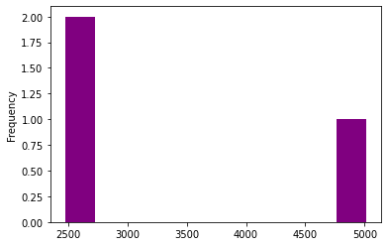

In [14]:

df**.**Age**.**describe()

Out[14]:

count 10000.000000

mean 38.921800

std 10.487806

min 18.000000

25% 32.000000

50% 37.000000

75% 44.000000

max 92.000000

Name: Age, dtype: float64

In [15]:

df**.**Age**.**plot(kind**=**'bar',color**=**"blue")

Out[15]:

<matplotlib.axes._subplots.AxesSubplot at 0x7fb7d8e723d0>

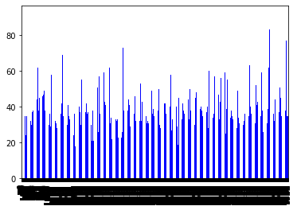

In [17]:

df**.**IsActiveMember**.**value_counts()**.**plot(kind**=**'bar',color**=**"pink")

df**.**IsActiveMember**.**value_counts()

Out[17]:

1 5151

0 4849

Name: IsActiveMember, dtype: int64

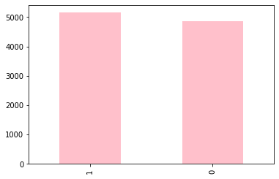

In [18]:

df**.**HasCrCard**.**value_counts()**.**plot(kind**=**'bar',color**=**"Orange")

df**.**HasCrCard**.**value_counts()

Out[18]:

1 7055

0 2945

Name: HasCrCard, dtype: int64

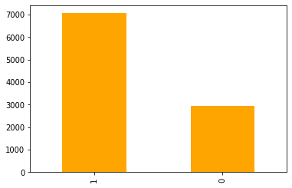

In [19]:

df**.**Tenure**.**value_counts()**.**plot(kind**=**'bar',color**=**"SkyBlue");

df**.**Tenure**.**value_counts()

Out[19]:

2 1048

1 1035

7 1028

8 1025

5 1012

3 1009

4 989

9 984

6 967

10 490

0 413

Name: Tenure, dtype: int64

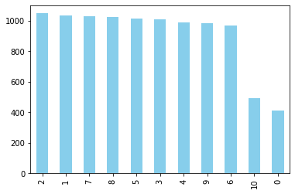

In [20]:

df**.**NumOfProducts**.**value_counts()**.**plot(kind**=**'bar',color**=**"black");

df**.**NumOfProducts**.**value_counts()

Out[20]:

1 5084

2 4590

3 266

4 60

Name: NumOfProducts, dtype: int64

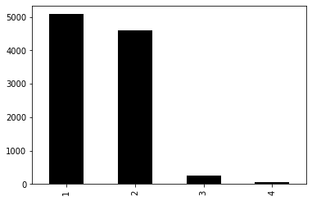

In [21]:

df**.**Exited**.**value_counts()**.**plot(kind**=**'bar',color**=**"darkgreen");

df**.**Exited**.**value_counts()

Out[21]:

0 7963

1 2037

Name: Exited, dtype: int64

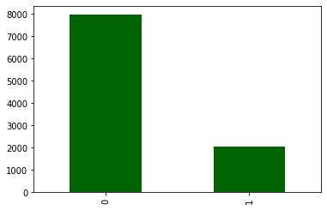

In [23]:

sns**.**countplot(x**=**df**.**Exited,hue**=**df**.**Gender,color**=**"Olive")

Out[23]:

<matplotlib.axes._subplots.AxesSubplot at 0x7fb7cbecd8d0>

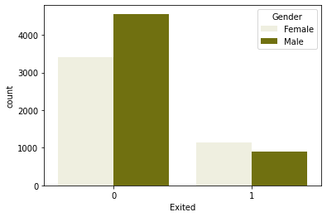

In [24]:

sns**.**countplot(x**=**df**.**Exited,hue**=**df**.**Geography,color**=**"cyan")

Out[24]:

<matplotlib.axes._subplots.AxesSubplot at 0x7fb7cbe0f510>

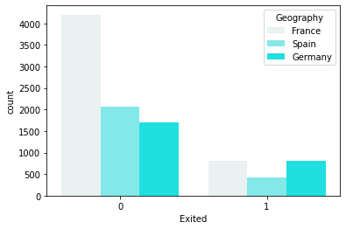

In [30]:

sns**.**countplot(x**=**df**.**Exited,hue**=**df**.**NumOfProducts,color**=**"fuchsia")

Out[30]:

<matplotlib.axes._subplots.AxesSubplot at 0x7fb7ca13cdd0>

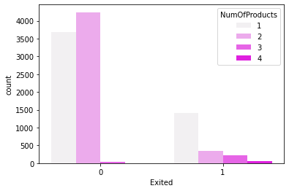

In [32]:

sns**.**countplot(x**=**df**.**Exited,hue**=**df**.**HasCrCard,color**=**"limegreen")

Out[32]:

<matplotlib.axes._subplots.AxesSubplot at 0x7fb7ca4cb990>

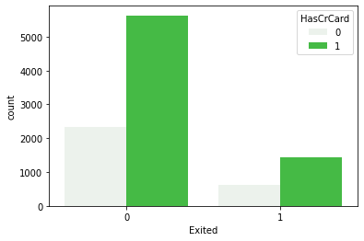

In [33]:

sns**.**countplot(x**=**df**.**Exited,hue**=**df**.**IsActiveMember,color**=**"aqua")

Out[33]:

<matplotlib.axes._subplots.AxesSubplot at 0x7fb7ca4d4c10>

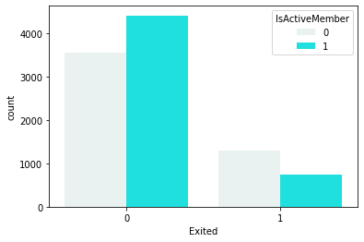

In [36]:

sns**.**boxplot(x**=**df**.**Exited,y**=**df**.**Balance,color**=**"turquoise")

Out[36]:

<matplotlib.axes._subplots.AxesSubplot at 0x7fb7c9ee8690>

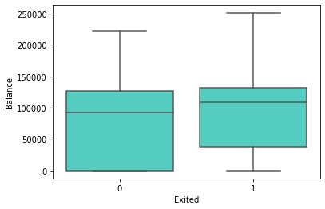

In [37]:

sns**.**countplot(x**=**"Gender",hue**=**"Exited",data**=**df,color**=**"coral")

Out[37]:

<matplotlib.axes._subplots.AxesSubplot at 0x7fb7c9eb3150>

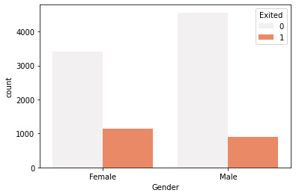

In [38]:

df['Geography']**=**df['Geography']**.**map({'France':0,'Spain':1,'Germany':2})

In [39]:

X**=**df**.**iloc[:,:**-**1]**.**values

y**=**df**.**iloc[:,**-**1]**.**values

In [40]:

X**.**shape

Out[40]:

(10000, 10)

In [41]:

*#Feature Scaling of Data Set*

le**=**LabelEncoder()

X[:,2]**=**le**.**fit_transform(X[:,2])

In [42]:

print(X)

[[619 0 0 ... 1 1 101348.88]

[608 1 0 ... 0 1 112542.58]

[502 0 0 ... 1 0 113931.57]

...

[709 0 0 ... 0 1 42085.58]

[772 2 1 ... 1 0 92888.52]

[792 0 0 ... 1 0 38190.78]]

In [43]:

scalerx **=** MinMaxScaler()

In [44]:

X **=** scalerx**.**fit_transform(X)

In [45]:

X_train, X_test, y_train, y_test **=**train_test_split(X,y,test_size**=**0.2, random_state**=**0)

In [46]:

stdscaler **=** StandardScaler()

X_train **=** stdscaler**.**fit_transform(X_train)

X_test **=** stdscaler**.**transform(X_test)